ODA - Oracle Dependency Analyzer

SQL Parser

Current state
In the complex select, where’re using view, internal query and select union is difficult to understand what is the source for the output column, which fields and which tables are ultimately used in the "where" clause.

The ODA solution
ODA SQL Parser is a tool that has been used the ODA repository information for SQL parsing any complex select used views and tables.
The ODA SQL Parser shows select fields and their source table columns.
The parser shows the source column and parsers functions and formulas in selected fields and “where” clause, internal queries in “from” clause.
The select is visualized as a tree and there is possible to navigate into column formulas and internal queries.
The target of select parsing is to show source table columns in any expression in select.

ODA Parser screenshots:

See Fig-1 example: The output column “eng_remark” in select is expression
Case When X.multi_elm_ind = 'N' Then X.eng_remark
Else Nvl(w.Elm_eng_remark, X.eng_remark) End eng_remark
Where “X” is alias for REPORTS.OCCFU_DEFIN table and “w” is alias for REPORTS.OCCFU_ELEM table.
There are using source columns reports.occfu_elem.elm_eng_remark and reports.occfu_defin.eng_remark.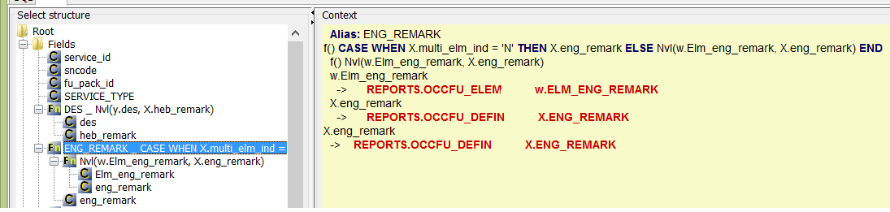

See Fig-2 example: The parsing of select

Select * from MGMT_RESPONSE_BASELINE
Where MGMT_RESPONSE_BASELINE is view with select
SELECT b.instance_number, s.sql_text, s.hash_value, v.address, s.t_per_exec
FROM dbsnmp.mgmt_baseline b, dbsnmp.mgmt_baseline_sql s, v$sqlarea v
WHERE b.instance_number = s.instance_number
AND s.hash_value = v.hash_value
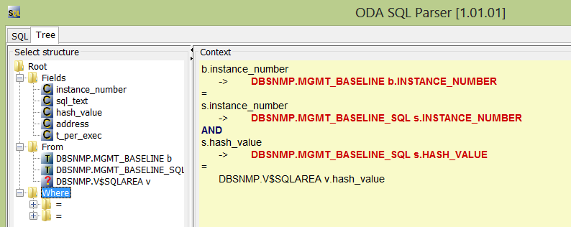
See Fig-3 example: The parsing of select
select mv.*,mv.instance_number inst from mgmt_availability mg,
(SELECT b.instance_number, s.sql_text, s.hash_value, v.address, s.t_per_exec
FROM dbsnmp.mgmt_baseline b, dbsnmp.mgmt_baseline_sql s, v$sqlarea v
WHERE b.instance_number = s.instance_number
AND s.hash_value = v.hash_value) mv
where mg.current_status=1 and mv.address=mg.target_guid